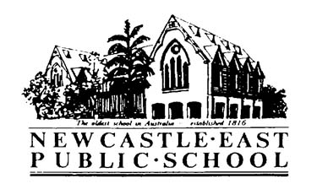
Primary Cross Country 2018
Thursday 15th March 2018
Dear Parents/Guardians,
Please see below for detailed information regarding the Primary Cross Country for 2018. Parents welcome!
Venue: | - Nesca Park  Cnr Nesca Parade & Brooks Street, Cooks Hill NSW 2300
Date: | - Wednesday 4th April 2018
Cost: | - $2 - this cost covers Newcastle Council’s hire fee
Students involved: | - All students in years 3-6
Time: | - 9:30am-11:00am (races will begin at approximately 9:45am)  - Students and teachers will depart NEPS at 9:00am and walk to the venue
Event order: | - 8/9 years boys/girls (2km)  - 10 years boys/girls (2km)  - 11 years boys/ girls (3km)  - 12/13 years boys/girls (3km)  - The first 3 students in each age group will be selected to represent Newcastle East P.S. at the Zone Cross Country at Stevenson Park in Mayfield on Friday 4th May
Uniform/Equipment: | - Students should wear a t-shirt in their sports house colour, comfortable running shorts and joggers  - Sunscreen and school hat  - Recess, lunch and lots of water to drink  - Asthma sufferers are permitted to carry their puffers for use during the race if needed
Back up dates: | - The slip below will cover parental consent if the carnival needs to be moved to a back up date
IMPORTANT: | - Please ensure your child applies sunscreen before school and drinks plenty of water to avoid dehydration  - Permission notes and payment due Thursday 29th March 2018

Laura Kirkman - Sports Coordinator

Primary Cross Country 2018
Permission & Medical Note
I give permission for my child________________________ of class _____ to walk under teacher supervision to and from Nesca Park to attend Newcastle East Public School’s Cross Country on Wednesday 4th April 2018.
Signature of parent/caregiver: _____________________________________ Date: _____________
I have included a payment of $________.
I have paid online. My POP number is_________________.
Special needs of my child:__________________________________________________________________________
_______________________________________________________________________________________________
Please return this slip and $2 to the office by Thursday 29th March 2018.

