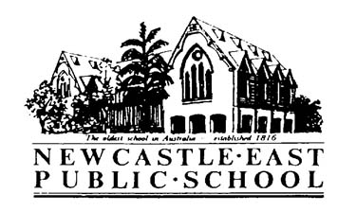
Newcastle East Public School
Term 1 Surfing

Dear Parent/Guardian,
Your child has expressed an interest in surfing for Term 1 sport and a position is offered to him/her. Please find detailed below information regarding this event.

Activity: | - Surfing
Venue: | - Nobbys Beach
Date: | - Friday 9.2.18 - 30.3.18 inclusive
Cost: | - $18.00 per week includes bus fare to and from Nobbys and a 45 minute lesson with professional coaches  - $144.00 per term to be paid in full to the office
Times: | - Bus leaves school at 8.45 PROMPTLY returning to school for recess at 10.45
IMPORTANT | - Please be at school by 8.30am and assemble on the COLA steps for roll marking
Manager: | - Laura Kirkman
Notes: | - Wear Swimmers under sports uniform and thongs or slip off shoes.  - Wear a wetsuit to school if you want to wear a wetsuit  - Apply sunscreen before school  - The surf school provides rash shirts, surfboards and leg ropes to all students for lessons  - Don’t forget to pack underwear, school shoes and socks and a towel for after the lesson  - Some children will get changed back at school others at Nobbys according to lesson times  - Notes due this Friday 2nd February 2018, full payment due by 23rd February 2018 (third week of surfing).
Don’t forget: | - Please label all of your child’s property.  - Please put your lunch order into the canteen before assembling on the steps  - Allow enough time for other tasks e.g. handing in homework etc.

Permission and Medical Note
Surfing for Sport Term 12018

I give permission for my child, _________________________________, to participate in surfing for sport in Term 1. Students will travel by bus, to and from Nobbys Beach for a 45 minute lesson with professional coaches every Friday for 8 weeks- 9.2.18-30.3.18 inclusive.

Signature of Parent/Caregiver:___________________________ Date:__________

Special needs of my child:

I have included payment of $144.00.
I have paid online. My POP number is______________

