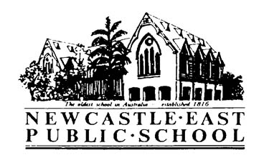
Primary Sport Term 2 – Empire Park
Wednesday 4th April, 2018
Dear Parents/Guardians,
Students in Years 3-6 will be travelling to Empire Park each Friday afternoon in Term 2 for sport. Students will participate in a range of games and sports including soccer, oztag, t-ball and more. Please see details below.
Venue: | - Empire Park  Memorial Dr, Bar Beach 2300
Dates: | - Friday 11th May – Friday 6th July
Cost: | - $30 - this cost covers bus fares and ground hire for the term
Students involved: | - All students in Years 3-6 (except those competing in PSSA netball and soccer competitions)
Supervising teachers: | - Miss Varagnolo - 2/3V, Mrs Powell - 3/4P, Mrs Enright - 3/4H & Miss Partridge - 4/5K
Transport: | - Bus
Time: | - Buses depart NEPS at 1:00pm  - Students return to NEPS by 2:45pm
Uniform/Equipment: | - Full sports uniform  - Sunscreen and school hat  - Water bottle  - Asthma puffer if needed
Additional information: | - Primary lunch time will be amended to 12:20pm on Fridays to allow for early bus departure  - Permission notes and payment due end of Week 1, Term 2 – Friday 4th May

Laura Kirkman - Sports Coordinator

Primary Sport Term 2 – Empire Park
Permission & Medical Note
I give permission for my child________________________ of class _____ to travel by bus to and from Empire Park, Bar Beach to participate in games and sports each Friday in Term 2, 2018 commencing Week 2 (11.5.18-6.7.18 inclusive).
I give permission for my child to receive medical attention if necessary.

I have included a payment of $________.
I have paid online. My POP number is_________________.
Special needs of my child:__________________________________________________________________________
Signature of parent/caregiver: _____________________________________ Date: _____________
Please return this slip and payment to the office by Friday 4th May 2018.

