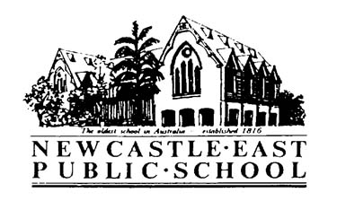
Harmony Day Assembly 1/2H
Dear Parents,
This year we will be holding a Harmony Day Assembly on Monday 19th March 2018 under the COLA from 8.45am. Harmony Day is a celebration of our cultural diversity – a day of cultural respect for everyone who calls Australia home.
Each class chooses a country and students study the culture and traditions, national dress, history and traditional foods from that country during a special day of lessons. Students also learn the importance of cultural diversity and celebrate out multi-cultural community.
This year our class will be learning all about People of the Arctic. We will be displaying some artwork painted by the students that was inspired by the well-known Canadian artist, Ted Harrison.
Students can come to school dressed in colours to represent a country of the Arctic or they may wear orange, the official colour of Harmony Day.

Kind Regards,
Kim Hadfield

