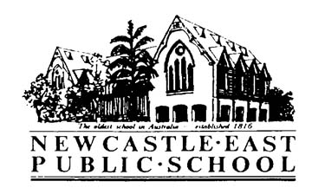
Primary Sport Term 2 – PSSA Soccer
Wednesday 4th April, 2018
Dear Parents/Guardians,
Congratulations, your child has been selected to represent Newcastle East Public School in the Newcastle PSSA (Primary Sporting Schools Association) Friday Soccer Competition. This competition will run during primary sport time every Friday in Term 2, 2018 (commencing Week 2).
Venue: | - Myer Park  Glebe Rd, Adamstown 2289
Dates: | - Friday 11th May – Friday 6th July
Cost: | - $30 - this cost covers bus fares and ground hire for the term
Students involved: | - Junior team (15) & senior team (15)
Supervising teacher: | - Mr Daniels
Transport: | - Bus
Time: | - Buses depart NEPS at 12:30pm for 1:00pm games  - Students return to NEPS by 2:45pm
Uniform/Equipment: | - Full sports uniform  - Sunscreen and school hat  - Long socks, shin pads and soccer boots  - Water bottle  - Asthma puffer if needed
Additional information: | - Primary lunch time will be amended to 12:20pm on Fridays to allow for early bus departure  - Shin pads and soccer boots must be worn during play. We have a tub of second-hand boots at school and students are welcome to take a pair from here if needed.  - Permission notes and payment due end of Week 1, Term 2 – Friday 4th May

Laura Kirkman - Sports Coordinator

Primary Sport Term 2 – PSSA Soccer
Permission & Medical Note
I give permission for my child________________________ of class _____ to travel by bus to and from Myers Park, Adamstown to participate in the Newcastle PSSA Soccer Competition each Friday in Term 2, 2018 commencing Week 2 (11.5.18-6.7.18 inclusive).
I give permission for my child to receive medical attention if necessary.

I have included a payment of $________.
I have paid online. My POP number is_________________.
Special needs of my child:__________________________________________________________________________
Signature of parent/caregiver: _____________________________________ Date: _____________
Please return this slip and payment to the office by Friday 4th May 2018.

