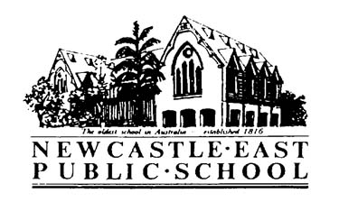

Consent Form
Newcastle Writers Festival- with Yvette Poshoglian
Dear Parents/Caregivers,

Please find below information regarding an excursion for students in 2/3V to attend an author presentation as part of the Newcastle Writers Festival.

Yvette Poshoglian, author of the Ella Diaries series, will explore what makes a great character and find out what the children’s favourite (fictional) people all have in common.

Please return the note to the school office, before Friday 23rd March, 2018.

Activity: | Newcastle Writers Festival
Venue: | Newcastle City Hall, Cummings Room
Date: | Friday 6th April: 1:15- 2pm
Classes Involved: | 2/3V
Cost: | Free
Travel will be by: | Walking
Supervision: | Class Teachers
Uniform/Equipment: | - Children are to wear school uniform.  - A broad-brimmed school hat while walking.

Permission and Medical Note

“Newcastle Writers Festival - at Newcastle City Hall – Friday 6th April

I give permission for my child__________________________________________of class _______ to attend

The Newcastle Writers Festival presentation at Newcastle City Hall, Friday 6th April, 2018.

Signed: ________________________________________ Date: ___________

Special Needs of my child:

___________________________________________________________________

