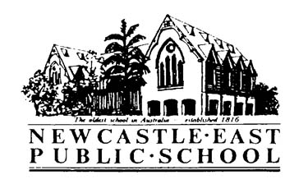

Consent Form
Newcastle Writers Festival- with Leigh Hobbs
Dear Parents/Caregivers,

Please find below information regarding an excursion for students in 4/5K to attend an author presentation as part of the Newcastle Writers Festival.

Students will create colourful characters with Children’s Laureate Leigh Hobbs, the artist who has created some of our best loved characters- Mr Chicken and Old Tom.

Please return the note to the school office, before Friday 23rd March, 2018.

Activity: | Newcastle Writers Festival
Venue: | Newcastle City Hall, Concert Hall
Date: | Friday 6th April: 9:30- 10:15
Classes Involved: | 4/5K
Cost: | Free
Travel will be by: | Walking
Supervision: | Class Teachers
Uniform/Equipment: | - Children are to wear school uniform.  - A broad-brimmed school hat while walking.

Permission and Medical Note

“Newcastle Writers Festival - at Newcastle City Hall – Friday 6th April

I give permission for my child__________________________________________of class _______ to attend

The Newcastle Writers Festival presentation at Newcastle City Hall on Friday 6th April, 2018.

Signed: ________________________________________ Date: ___________

Special Needs of my child:

___________________________________________________________________

