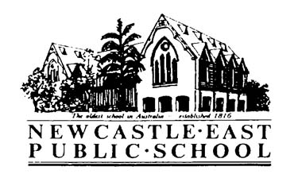
Dear Parents and Caregivers,
Your child has been offered the chance to take part in the 2018 Young Leader’s Day Conference held on the 12th March at the Sydney International Conference Centre. This day will provide students with valuable skills and resources to help develop their personal leadership abilities. Please see details below:
Date | Friday 12th March, 2017
Cost | Newcastle East will cover all costs
Transport | We will be travelling by coach, along with other students from the local area. No cost involved for students.
Time | Students are to be at Adamstown Public School at 5:45am for a departure time of 6:00am.  Arrival at Adamstown Public School between 5:00pm-5:30pm
Food | Please bring a packed lunch and recess, including a drink. If you would like to provide your child with a small amount of money please do. However, we cannot be sure if food will be available on the day.
Uniform/Equipment | Please ensure full school uniform is worn. This will include a hat.
Supervision | Students will be accompanied with Mrs Thompson.

Please fill in all relevant permission below and hand back to Mr Daniels as soon as possible.
Regards,
Todd Daniels Mick McCann
Assistant Principal Principal

Permission and Medical Note
Young Leaders Conference – Sydney International Conference Centre, 12th March 2018
I give permission for my child……………………………………. of class………………. to attend Young Leaders Conference – Sydney International Conference Centre, 12th March 2018
Signed: ________________________________________ Date: _____________

Special Needs of my child: ____________________________________________________

