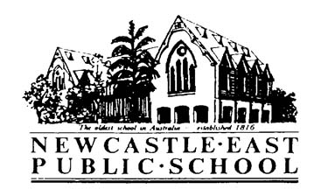

**banner with apples and crayons**

1/2H parent information

**Homework**In 1/2H will be sent home on Monday and due back by Friday. This is beneficial revision of the new concepts we are learning in class and should only take 15 minutes each night.

Department of Education guidelines state that homework is optional. Please contact me if you do not wish for your child to complete homework. There will be no rewards for completing homework and no punishment for not completing homework.

**Birthdays**I ask that parents do not send birthday cakes into school on their child’s birthday. This is due to the possibility of children with anaphylaxis reacting to certain foods.

**Crunch and Sip**Each day the children are required to bring food and water for ‘Crunch and Sip’. These sessions give the students a short fruit and drink break and allow them to refuel. Suitable foods include: fresh fruit, dried fruit, fruit yogurt, vegetables and fruit in juice.

**Library**Library lessons take place every Wednesday. Children are encouraged to bring any sort of bag (cloth or plastic) to school on their Library day.

**Classroom Supplies**

Below is a list of items students will need to bring to school to assist with the running of our classroom.

* A pump bottle of hand sanitizer
* A box of tissues
* 2 glue sticks
* A set of headphones/earbuds
* A water bottle and hat (every day)

**Teachers**During the school week, the children will be taught by different members of the N.E.P.S staff. These may include:

Mr Ringis - STEM (Science/Technology/Engineering/Mathematics)

Mrs Zeita Mason - Library

Mrs Yasmin McNamee- Learning Assistance Support Teacher and EAL/D

**Parent Helpers**At different times throughout the year, parents will be invited into the classroom to assist with various activities.

All parents helping in the classroom are required to sign in at the office before entering the classroom.

Regards,

Mrs Kim Hadfield

kim.hadfield@det.nsw.edu.au