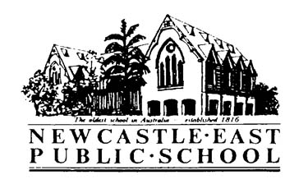
Newcastle Zone Swimming Carnival 2018
Thursday 8th February 2018
Dear Parents/Guardians,
Your child has qualified to represent Newcastle East Public School at the 2018 Newcastle Zone Swimming Carnival. Please see below for detailed information regarding the Newcastle Zone Swimming Carnival.
Venue: | - Lambton Pool
Date: | - Monday 26th February 2018
Cost: | - $7.00. This fee covers pool entry and Newcastle Zone PSSA levy.  - Spectators are charged for entry.
Time: | - 9:00am-3:00pm  - Please meet Mrs Kirkman out the front by 8:40am. All competitors must be seated inside by 8:50am.
Transport: | - Parents are required to transport their child to and from the venue. Lists of all zone competitors are on all classroom doors if parents wish to coordinate car pools.
Supervision: | - As Mrs Kirkman will have official duties on the day, a parent helper is needed for supervision. Please contact Mrs Kirkman or the office if you are able to assist with this. A current Working with Children Check (Volunteer) is required. This is free through Service NSW.
Events: | - All Age Championship 100m freestyle  - Age Championships 50m freestyle (8, 9, 10, 11, 12, 13 years)  - 50m backstroke, 50m breaststroke, 50m butterfly (junior, 11 years, 12/13 years)  - 200m relay (junior, senior)  - 200m medley (junior, senior)
Uniform/Equipment: | - Sports uniform (yellow shirt) should be worn over the top of swimmers.  - Sunscreen and a broad-brimmed hat. Rash-shirts are also advisable.  - Please also pack a towel, goggles, recess, lunch and lots of water to drink.  - The pool’s canteen facilities will also be available throughout the day.
Back up dates: | - The slip below will cover parental consent if the carnival needs to be moved to a back up date.
IMPORTANT: | - Please fill out the attached Medical Information Form and return it with the permission note below. This is a requirement for all competitors.  - Permission notes and full payment must be made to the office by Thursday 22nd February 2018, or students will not be allowed to participate in the carnival.
Permission Note
Newcastle Zone Swimming Carnival 2018
I give permission for my child________________________ of class _____ to attend Newcastle Zone Swimming Carnival on Monday 26th February 2018 at Lambton Pool. I will arrange transport to and from the venue for my child.

I have filled out and attached the medical information form.
Signed: _____________________________________ Date: _____________
I have included a payment of $________.
I have paid online. My POP number is_________________.
Please return this slip to the office by Thursday 22nd^{t} February 2018 with full payment and medical form.

