Wednesday, 31st February, 2018
Dear Parents and Carers,
Welcome to the new school year. My name is Megan Thompson and I am delighted to be teaching your child this year. Our class is a composite class composed of eleven Year 5 and eighteen Year 6 students and will be known as 5/6T. Here is a list of items your child will be required to supply at school as soon as possible:
- 3 HB lead pencils
- 3 red ball point pens
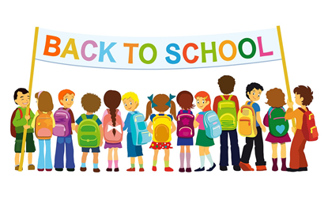
- 3 blue ball point pens (no felt tip or gel pens please)
- ruler
- sharpener (preferably with a case to catch pencil shavings)
- small, compact pencil case
- coloured pencils
- textas
- glue stick
- scissors
- 1 box of tissues
- headphones
- USB stick
- homework book – 96 pages A4 size, covered and labelled please.
- whiteboard marker
- library bag
- novel to read in class
- protractor (180◦)
- simple calculator with M+ and MR functions
- pocket dictionary
- geometry compass
- These items are not compulsory, but will ease demand on school equipment
This week I have set some homework for you! In order for me to get to know your child better, I would appreciate it if you could complete the attached information sheet about them. Please feel free to add more information if you wish. Completed questionnaires can be placed in the box just inside our classroom door. I look forward to guiding your child through their final stage of schooling at Newcastle East and we hope to meet you all soon.
Kind regards,
Megan Thompson (Class Teacher) Mick McCann (Principal)
megan.thompson@det.nsw.edu.au

