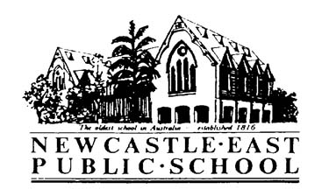
Easter Hat Parade
Dear Parents/Caregivers,
Our Easter Hat Parade will be held on Thursday 29th March at 2:00pm under the COLA. This event is not religious based but will give each student the opportunity to showcase their fabulous craft skills and hats.
In preparation for this event, KM and K1K will be having a hat making afternoon. This will be held on Wednesday 28th March, from 1:45-2:45pm. Parents and grandparents are invited to come along and help the students create spectacular hats. The more helping hands the better. Each child needs to bring to school their own Easter decorations and something to construct a hat out of. The hat could be made from a piece of cardboard or they could decorate an existing hat. I will supply glue, scissors, staplers and lots of inspirational ideas. Those students who wish to create their hat at home are encouraged to help others.
Thank you for your cooperation.
Kind regards,
Sarah Kerr and Fiona Miller
