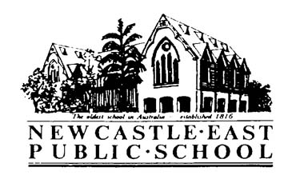

Consent Form
Newcastle Writers Festival- with Tristan Bancks
Dear Parents/Caregivers,

Please find below information regarding an excursion for students in 5/6T to attend an author presentation as part of the Newcastle Writers Festival.

Tristan will take students behind the scenes of his new crime mystery novel "The Fall" and his CBCA Honour book "Two wolves". The presentation will be full of laughs and valuable tips on how students can use their own lives to feed their stories.

Please return the note to the school office, before Friday 23rd March, 2018.

Activity: | Newcastle Writers Festival
Venue: | Newcastle City Hall, Hunter Room
Date: | Friday 6th April: 9:30- 10:15
Classes Involved: | 5/6T
Cost: | Free
Travel will be by: | Walking
Supervision: | Class Teachers
Uniform/Equipment: | - Children are to wear school uniform.  - A broad-brimmed school hat while walking.

Permission and Medical Note

“Newcastle Writers Festival - at Newcastle City Hall – Friday 6th April

I give permission for my child__________________________________________of class _______ to attend

The Newcastle Writers Festival presentation at Newcastle City Hall on Friday 6th April, 2018.

Signed: ________________________________________ Date: ___________

Special Needs of my child:
___________________________________________________________________

